Name : Maiyani Gautam Sureshbhai
Branch : CSE
Sub : DBMS
Seat No : 312025
Batch : Y-batch
Prn : 2020033800100853
E-mail : gautammaiyani2332@gmail.com
Mob. No: 9067548332
ASSIGNMENT-1(0)

SUPPLIER(SID, SNAME, CITY)
PART(PID, PNAME, COLOR)
CATALOG(SID, PID, COST)
- Create the above tables with necessary constraints.

create table Supplier(
sid int primary key,
sname varchar(20) not null,
city varchar(20) not null );

create table Part(
pid int primary key,
pname varchar(20) not null,
color varchar(20) not null );

create table Catalog(
sid int not null,
pid int not null,
cost int not null,
constraint fk_sid primary key(sid,pid),
foreign key(sid) references Supplier(sid),
foreign key(pid) references Part(pid) );
2. Insert values in all the tables.
>Inserting values into Supplier table
insert into Supplier(sid,sname,city) values(1,'Raj','Mumbai');
insert into Supplier(sid,sname,city) values(2,'Andy','Bangalore');
insert into Supplier(sid,sname,city) values(3,'Rajesh','Chennai');
insert into Supplier(sid,sname,city) values(4,'Patel','Delhi');
select * from Supplier;
Output:
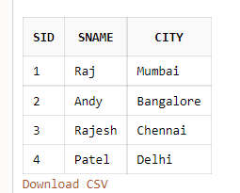
>Insert values into Part table
insert into Part(pid,pname,color) values(110,'Wood','Red');
insert into Part(pid,pname,color) values(111,'Wood','Green');
insert into Part(pid,pname,color) values(112,'Timber','Blue');
insert into Part(pid,pname,color) values(113,'Timber','Yellow');
select * from Part;
Output:
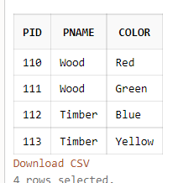
>insert values into Catalog table
insert into Catalog(sid,pid,cost) values(1,110,70);
insert into Catalog(sid,pid,cost) values(2,111,5000);
insert into Catalog(sid,pid,cost) values(3,112,1070);
insert into Catalog(sid,pid,cost) values(4,113,200);
select * from Catalog;
Output:
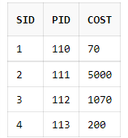

3. Add a column WEIGHT to the PART table
alter table Part add Weight varchar(10);
Output:
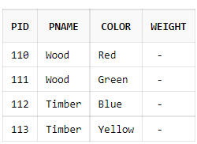

4. Add a constraint to the SUPPLIER table which will allow the CITY column to have MUMBAI, DELHI, BANGALORE, KOLKATA or CHENNAI as the value only.
alter table Supplier add constraint ck_city check(city in(‘Mumbai’,’Bangalore’,’Delhi’,’Kolkata’,’Chennai’));
5. Change the colour of part 111 to grey.
update Part set color='Grey' where pid=111;
Output:
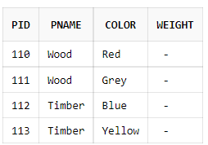

6. Change the city of supplier PATEL to MUMBAI.

update Supplier set city='Mumbai' where sname='Patel';
Output:
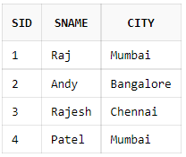

7. Delete all records from the CATALOG table where cost is more than 100 and less than 500.

delete from Catalog where cost>100 and cost<500;
Output:
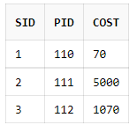

8. Add a column COUNTRY to table SUPPLIER.
alter table Supplier add Country varchar(20);
Output:
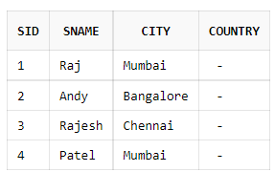

9. Add values to the COUNTRY column.

update Supplier set Country='India';
Output:
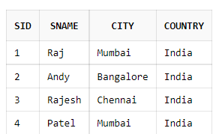

10.Increase the size of COLOR column and decrease the size of PNAME column.
alter table Part modify Color(40);
alter table Part modify pname(7);
Output:
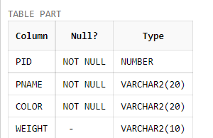

11.Display supplier details of suppliers located at CHENNAI.

select * from Supplier where city='Chennai';
Output:
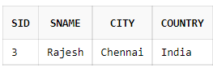

12.Display SID and PID where cost is between 1000 and 5000.
select sid,pid from Catalog where cost between 1000 and 5000;
Output:
